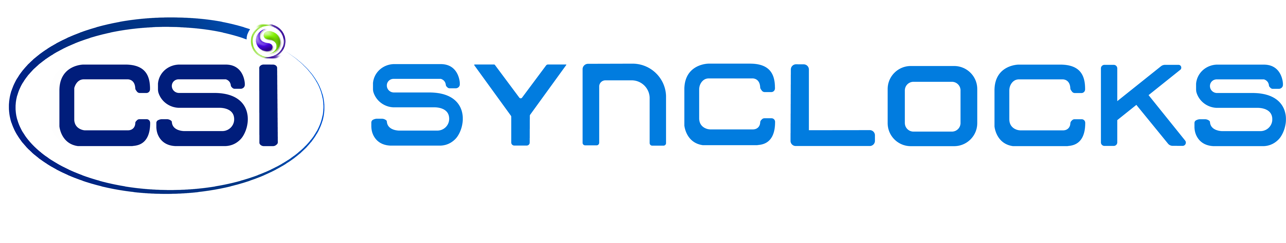
The Importance of Time Synchronization

The Importance of Time Synchronization

In the rapidly expanding healthcare industry, the concept of "wasting time" is a rare occurrence. Medical facilities face the ongoing challenge of managing daily operations related to patient care and hospital maintenance. Given the critical role of time in healthcare services, hospitals heavily rely on strategically placed clocks throughout their facilities. Whether it's doctors, nurses, or other personnel engaged in medical practices, precise timekeeping is crucial for providing prompt and effective service. The essential nature of time in healthcare emphasizes the need for healthcare providers to utilize time effectively, efficiently, and accurately in various aspects of their services. This necessity becomes evident when considering technological issues, medication dispensation, surgery procedures, and the scheduling of daily appointments.

Safety

Amidst an increase in potential threats, schools prioritize implementing proper procedures to ensure students are well-prepared to respond in case of an emergency. Synchronized Digital Clocks offer a dependable solution to enhance safety measures across facilities. Featuring the capability to transmit messages for mass notification, Digital Clocks can display concise 4 to 6 character messages such as “FIRE” or “911”. These messages serve as visual aids during chaotic situations, contributing to safety guidance and overall emergency preparedness.

Reducing Maintenance Costs with an Internal Time Server

Efficiently managing systems in higher education, which may span from a single building to multi-campus infrastructures, can be time-consuming and costly. However, we offer a solution to reduce additional costs and streamline maintenance. With a system, facilities can synchronize any IP device, including security cameras, phones, computers, etc., to a central NTP Master Clock time server. This approach ensures that all devices receive accurate time from a unified NTP server/time source, simplifying system management.

Handling Daylight Saving Time and Time Drifting Efficiently

Eliminate the need for climbing ladders, removing clocks, and adjusting the time twice a year with a Sapling synchronized system. Changing clocks for Daylight Saving Time (DST) can be a time-consuming task, especially in larger facilities with multiple maintenance workers. Non-synchronized systems may also experience time drift over time, leading to significant discrepancies unless manually corrected. The implementation of a synchronized system with autocorrecting clocks helps eliminate these maintenance challenges.

Multi-Campus & Building Time Synchronization

One significant advantage of Synchronized Clock System is the capacity to maintain accurate time across multiple buildings, whether the campus is centralized or dispersed across one or more states. This feature enhances time management accountability for students and faculty while promoting overall efficiency throughout the campus.

Preventing Distractions

While smart devices play a crucial role in society, they can also be distracting. Students may start by checking the time but end up getting drawn into social media, contacting friends, or playing games. Similarly, professors might find themselves checking emails, calendars, and personal messages. Synchronized Clock Systems encourage students and faculty to stay focused and be present in the moment, enhancing the overall learning experience and reducing the temptation of smart device distractions.

Enhancing Seminars and Presentations

An additional feature Sapling provides is a countdown clock used for seminars and presentations. Sapling offers an elapsed timer control panel that connects directly to a clock. With the push of a button, faculty can provide a prescheduled countdown to a classroom clock, keeping a seminar or lecture on schedule. Another benefit is timed presentations for students keeping classes on track when there are multiple presenters.

CSI Solutions

CSI’s state of the art systems provide low maintenance costs, campus wide safety features, consistent time synchronization all year round, etc. Whether choosing Wired, Wireless, IP, or a combination, a Sapling solution can meet all of your needs. Check out our systems page for more information.

