Impact of IP Clocks on Cost and Energy Efficiency Throughout Your Clock System's Lifespan

Managing operational costs is a priority for companies and organizations, and one significant area of focus is energy expenditure. The escalating costs of energy have prompted many entities to explore strategies for reducing these expenses, redirecting the savings to other essential areas. The digital IP Clock System, designed for various industries, not only provides precise time synchronization but also offers an energy-efficient solution.

The digital IP Clock System operates on Power over Ethernet (PoE), delivering both power and data through a single CAT5 or CAT6 cable, eliminating the need for additional outlets. Each clock in the IP system can synchronize its time with a network-connected (S)NTP time server, ensuring uniform time across all networked clocks. The clocks feature a built-in web interface accessible from any network-connected computer, allowing facility managers to monitor and adjust various settings.

One notable energy-saving feature is the brightness setting, accessible through the web interface. Facility managers can customize the brightness levels for individual clocks in real-time, with options such as High, Medium, Low, or Off. The Brightness Schedule feature, enabling users to preset alternate brightness levels based on specific days, times, and desired brightness levels (High, Medium, Low, or Off). This scheduling flexibility caters to diverse facility needs and further contributes to energy conservation.

By leveraging the capabilities of the digital IP Clock System, organizations can not only enhance timekeeping accuracy but also implement effective energy management strategies. Access to real-time brightness adjustments and the ability to schedule brightness variations empower facility managers to optimize energy consumption and reduce associated costs efficiently.

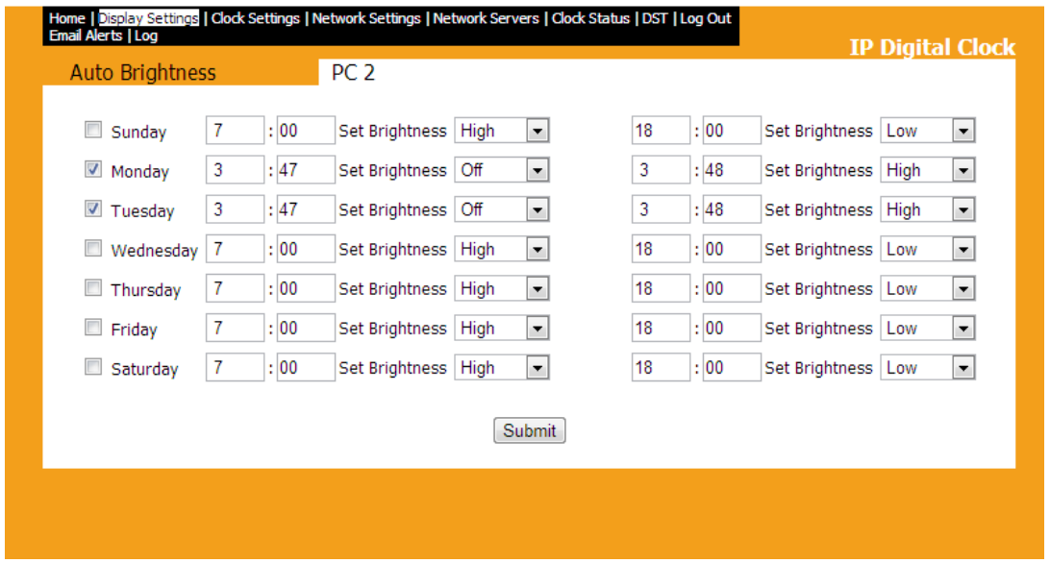

In a school setting, for instance, when students, teachers, and staff typically arrive at 8 am, the facility manager can strategically schedule the clock brightness to be at its highest by 7:00 am when everyone begins to arrive. At the end of the school day, the manager can set the clocks to turn off at 5:30 p.m., ensuring energy efficiency after everyone has left the building. Utilizing the Brightness Schedule allows the clock displays to be adjusted to low or turned off entirely during unoccupied hours, contributing to cost savings and aligning with green initiatives.

In a hospital environment, the Brightness Schedule proves beneficial for both employees and patients. With constant activity in a hospital, facility managers can program digital clocks in patient rooms to dim at 7 pm, enhancing the patient's comfort during rest hours. Simultaneously, clocks in hallways and nurse's stations can be set to high or medium brightness for clear visibility for staff. This feature extends its advantages to various industries, illustrating its versatility.

Energy conservation is now a fundamental aspect of successful organizational management. By incorporating the Brightness Schedule into facility operations, managers can effectively reduce the energy consumption of the clock system. This not only promotes enhanced energy efficiency but also aligns with sustainable business practices, ultimately reducing overall energy expenses. Choosing digital IP clock system ensures the installation of an accurate, reliable clock system while actively curbing unnecessary energy costs.

In its commitment to aiding organizations in energy conservation, incorporated energy-efficient technology into each clock, setting it apart from competitors. The following page provides a comparative analysis, highlighting how 2.5” and 4” digital clocks outperform those of competitors."
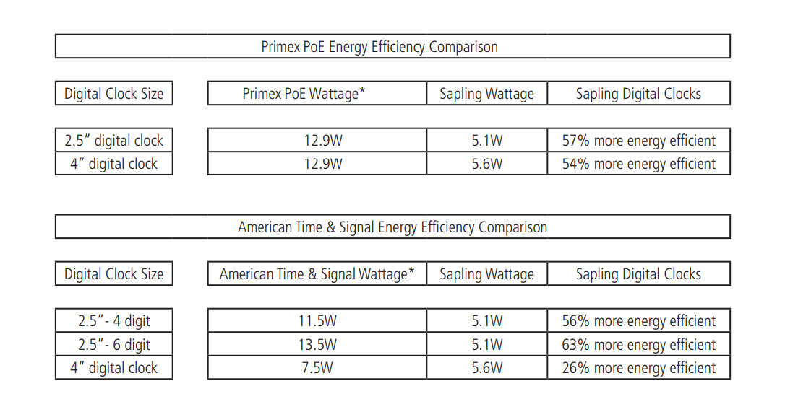
*Wattage information for the Primex PoE Digital Clocks available at Primex's website as of August 2019.
*Wattage information for the American Time & Signal PoE Digital Clocks available at American Time & Signal's website as
of August 2019.

